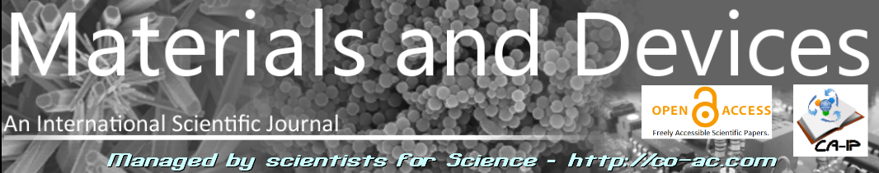
Article type: A-Regular research paper ; L-Short paper; R-Review article ; Conf.-Conference paper (ACRONYM of the event); T-Technical paper ; Ur-Unexpected results
(delete irrelevant items)

Title of the article
eventual subtitle

M. Alfron (1), A. Dupond (2), O. Popov (3), T. Shiaoshi (4)
(1) Laboratory name, University, Country, e-mail address
(2) Laboratory name, University, Country, e-mail address
(3) Laboratory name, University, Country, e-mail address
(4) Laboratory name, University, Country, e-mail address

Corresponding author : e-mail@address
RECEIVED: 12 november 2016 / RECEIVED IN FINAL FORM: 25 december 2016 / ACCEPTED: 04 january 2017

Abstract : the abstract will be written in fontsize 8. It should represent the content of the paper and should not exceed 10 lines. Please do not use abbreviations in the abstract.
Keywords : list at least 5 keywords in english separated by comas, use fontsize 8 and capital letters, for instance ECOMATERIALS, SEMICONDUCTORS, NANOMATERIALS, OXIDES, etc
Cite this article: authors, OAJ Materials and Devices, Vol 4 #1, XXXX (2019) – DOI: 10.23647/ca.md2017XXXXX

Introduction
NEW! We are aware of the time losses due to preparation of manuscripts in different formats to fulfill requirements of different journals.
For this reason, in order to save your time, we decided to accept submissions of new articles in any form: when submitting your article, you may now submit a file edited freely, without following any template. We only ask you to number lines, formula, figures and tables. Thereafter submit a pdf generated from your manuscript.
We shall ask you to prepare the final version of your manuscript at final stage, when and if your article is accepted following recommendations of reviewers.
If you choose to edit your article as an .odt document, please use this template with care. Please NOTE THAT FOR REVIEW ARTICLES THE TEMPLATE IS DIFFERENT! Do not change the format (use fontsize 8), and proceed by replacing the text in the present document by your own text. If necessary, you can introduce new paragraphs generated from the present model of paragraph, but without changing the format.
It is recommended to use the last stable official version of Libre Office, that you can download at www.libreoffice.org/. A manual for using Libre Office or Open Office to edit a scientific article containing formula can be found here :
https://wiki.documentfoundation.org/images/3/37/MG40-MathGuide.pdf
For each part you copy or edit in the present document, check that the result is in agreement with the present model, and that the format has not been accidentally changed in the meantime.

Second paragraph
Copy this paragraph as many times as you need.
If you need to introduce equations, use the Libre Office facilities available in the software.
Equations need to be numbered. The number will be indicated as follows, for instance (1), located on the right side; use preferentially the function integrated in Libre Office named “autotext” accessible through menu > edition or through a shortcut dependent of the language version of Libre Office, often fn+F3 or Ctrl+F3 (see for more details :
https://wiki.openoffice.org/wiki/Documentation/OOo3_User_Guides/Writer_Guide/Numbering_equations (1) .
An advantage of automatic numbering of equations is that you can cite equations in the text using crossreference, which modifies automatically the numbering if you introduce changes, for instance if you delete an equation.
$$f\left(x\right)=\frac{1}{σ\sqrt{2π}}e^{−\frac{{\left(x−μ\right)}^{2}}{2σ^{2}}}$$ | (1)

Equations should be centered in the paragraph. In the text refer to equations as eq. (1), (2), ...
Please do not forget to introduce the signification of abbreviations the first time they are introduced. Concerning references, they should appear in the text as a number between brackets, in the order of appearance, and as superscript in the text for instance as ^{[3]}. All references will be located at the end of the document, in the space left for it. Please follow the format for references therein. Beware to use the standard abbreviation of cited journals according to the ISSN List of Title Abbreviation (see http://www.issn.org/2-22661-LTWA-online.php). In the references, if the DOI (Digital Object Identification) of cited articles is available, it is better (but not mandatory) to mention it.
Figures should be also centered in the text. In principle, they should occupy no more that one column, but in particular cases where it should be larger, a figure could occupy the whole width of the page.
Take care that the figure and the caption should be displayed in the same column. Figures should have a caption as follows :
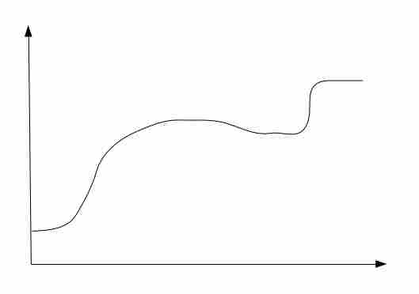

Figure 1: Title of the figure – bold, fontsize 9
Comments (fontsize 7), indicate clearly which quantities are along vertical and horizontal axes; check that the figure may be read easily, labels of axes, in particular, should be present and large enough to be read without problem. Take care also of the size of the pictures : avoid pictures with a size exceeding 500 ko. Finally check that the figure caption appears entirely below the figure.(here is an example of what should not be done !)

Tables will be centered, and numbered according to the order of their appearance in the text. Tables should not be cut into several pieces, either between different pages, or between different columns. Prefer tables occupying one column, but if necessary a table can occupy the whole width of the page.Table title and caption will be above the table itself as follows :

Table 1 : Title of the table (centered)

Third paragraph
Copy the model of paragraph given by “second paragraph” as many times as you need. Last paragraph should concern conclusion.
In this template, we now take opportunity to say some words about Open Access and the philosophy of this journal.
According to the “Budapest Open Access Initiative” (see http://www.budapestopenaccessinitiative.org/): “in response to the growing demand to make research free and available to anyone with a computer and an internet connection, a diverse coalition has issued new guidelines that could usher in huge advances in the sciences, medicine, and health.
The recommendations were developed by leaders of the Open Access movement, which has worked for the past decade to provide the public with unrestricted, free access to scholarly research—much of which is publicly funded. Making the research publicly available to everyone—free of charge and without most copyright and licensing restrictions—will accelerate scientific research efforts and allow authors to reach a larger number of readers.
The recommendations are the result of a meeting organized by the Open Society Foundations to mark the tenth anniversary of Budapest Open Access Initiative, which first defined Open Access. The recommendations include the development of Open Access policies in institutions of higher education and in funding agencies, the open licensing of scholarly works, the development of infrastructure such as Open Access repositories and creating standards of professional conduct for Open Access publishing. The recommendations also establish a new goal of achieving Open Access as the default method for distributing new peer-reviewed research in every field and in every country within ten years’ time.”
Generally, Open Access Journals (or Open Access option in traditional journals) are not free of charge for authors: the fees vary between approximately 100 € and 9000 € per article. Traditional journals propose now frequently an Open Access option, that makes your article openly accessible, but this is not a free service. However in both cases, Open Access and traditional editing, reviewers do their work without any charge for the journal. Materials and Devices is edited by the scientific association COLLABORATING ACADEMICS, and the bet we make, which is a challenge, is that because of volunteerism, the journal is and will remain free of charge for authors.
As a result, you don't need to pay for publishing your article in Materials and Devices, and you may use and distribute freely copies of your paper, and, what is important, you remain owner of the article content. However beware that if you do not respect this template, which would induce additional work for us, you will be charged by an inclusive fee of 100€ if your paper is accepted and if you do not submit a final version according to this template.
There is an interesting site, in which you can check publisher copyright policies and self-archiving, called sherpa/romeo. You should absolutely consult it before distributing your articles through internet if it is published in a traditional journal (it may be forbidden by some editor to distribute or self-archive your work):
http://www.sherpa.ac.uk/romeo/index.php
You can use your article without limitation if it is published in Materials and Devices. Your submission of articles and your involvement in the journal or in Collaborating Academics are welcome!

Conclusion
This paragraph should resume as clearly as possible the results you obtained, underlying the most important points and probable, eventual future prolongations of the work.

Acknowledgements:
Please locate eventual acknowledgements here following this format.

REFERENCES
- R.FirstName, H.SecondName, O.Etc, Journal of Experimental Science, vol.4, p 18 (2014)
- R.FirstName, H.SecondName, O.Etc, Title-of-the-paper, in Title-of-the-book, Editor, Place (Year)
- etc you can also use for references the automatic numbering provided by the text editor.

IMPORTANT:
Please prepare a list of e-mail addresses of scientists working in the field of this article, or in related fields (at least 15 addresses) (Requested by the journal, will not appear in the published article) and send that list together with the manuscript by e-mail to editor.materialsanddevices@gmail.com
adresses should be separated by coma, as name1@univ1.net, name2@univ2.com, …
THEREAFTER REMOVE THIS PART UNDERLINED IN YELLOW FROM YOUR MANUSCRIPT!

Important: Articles are published under the responsability of authors, in particular concerning the respect of copyrights. Readers are aware that the contents of published articles may involve hazardous experiments if reproduced; the reproduction of experimental procedures described in articles is under the responsability of readers and their own analysis of potential danger.

Reprint freely distributable – Open access article

Permissions – Important: all materials in this article may be freely reused (figures, tables, …)
without any need to ask permission or to pay any fee. It is simply asked to refer to the article.

Materials and Devices is an Open Access journal which publishes original, and peer-reviewed papers accessible only via internet, freely for all. Your published article can be freely downloaded, and self archiving of your paper is allowed and encouraged! Put your article as soon as possible on your personal sites, institutional sites, etc!
We apply « the principles of transparency and best practice in scholarly publishing » as defined by the Committee on Publication Ethics (COPE), the Directory of Open Access Journals (DOAJ), and the Open Access Scholarly Publishers Organization (OASPA). The journal has been designed so that it can be accepted by DOAJ, and we are happy to inform you that this is the case now.

Copyright on any article in Materials and Devices is retained by the author(s) under the Creative Commons (Attribution-NonCommercial-NoDerivatives 4.0 International (CC BY-NC-ND 4.0)), which is favourable to authors.
Aims and Scope of the journal : the topics covered by the journal are wide, Materials and Devices aims at publishing papers on all aspects related to materials (including experimental techniques and methods), and devices in a wide sense provided they integrate specific materials. Works in relation with sustainable development are welcome. The journal publishes several types of papers : A: regular papers, L : short papers, R : review papers, T : technical papers, Ur : Unexpected and « negative » results, Conf: conference papers, and O: Opinion papers.
(see details in the site of the journal: http://materialsanddevices.co-ac.com)
Important: all submitted articles, fullfilling above indications, are evaluated by peers from a pure scientific point of view! The editor-in-chief does not take any right of censorship, whether on the basis of the subject of the article, or the strength of the “profile of the authors”, their reputation, or other. We do not take any action to mechanically optimize the impact factor of the journal, for example by analyzing the forecast number of citations of the article based on the number of scientists working in the field, or fashion effects, or other.
We want to maintain Materials and Devices Open Access and free of charge thanks to volunteeriing, the journal is managed by scientists for science! You are welcome if you desire to join the team!
Advertising in our pages helps us! Companies selling scientific equipments and technologies are particularly relevant for ads in several places to inform about their products (in article pages as below, journal site, published volumes pages, …). Corporate sponsorship is also welcome!
Feel free to contact us! contact@co-ac.com

